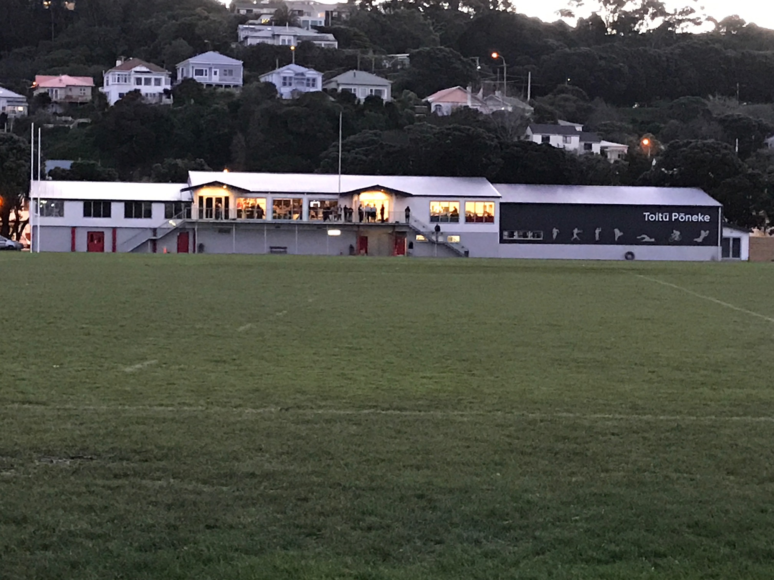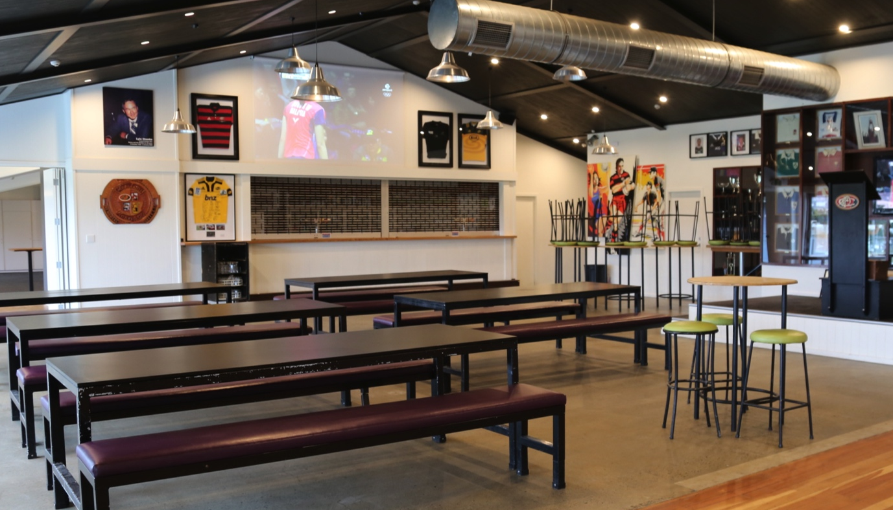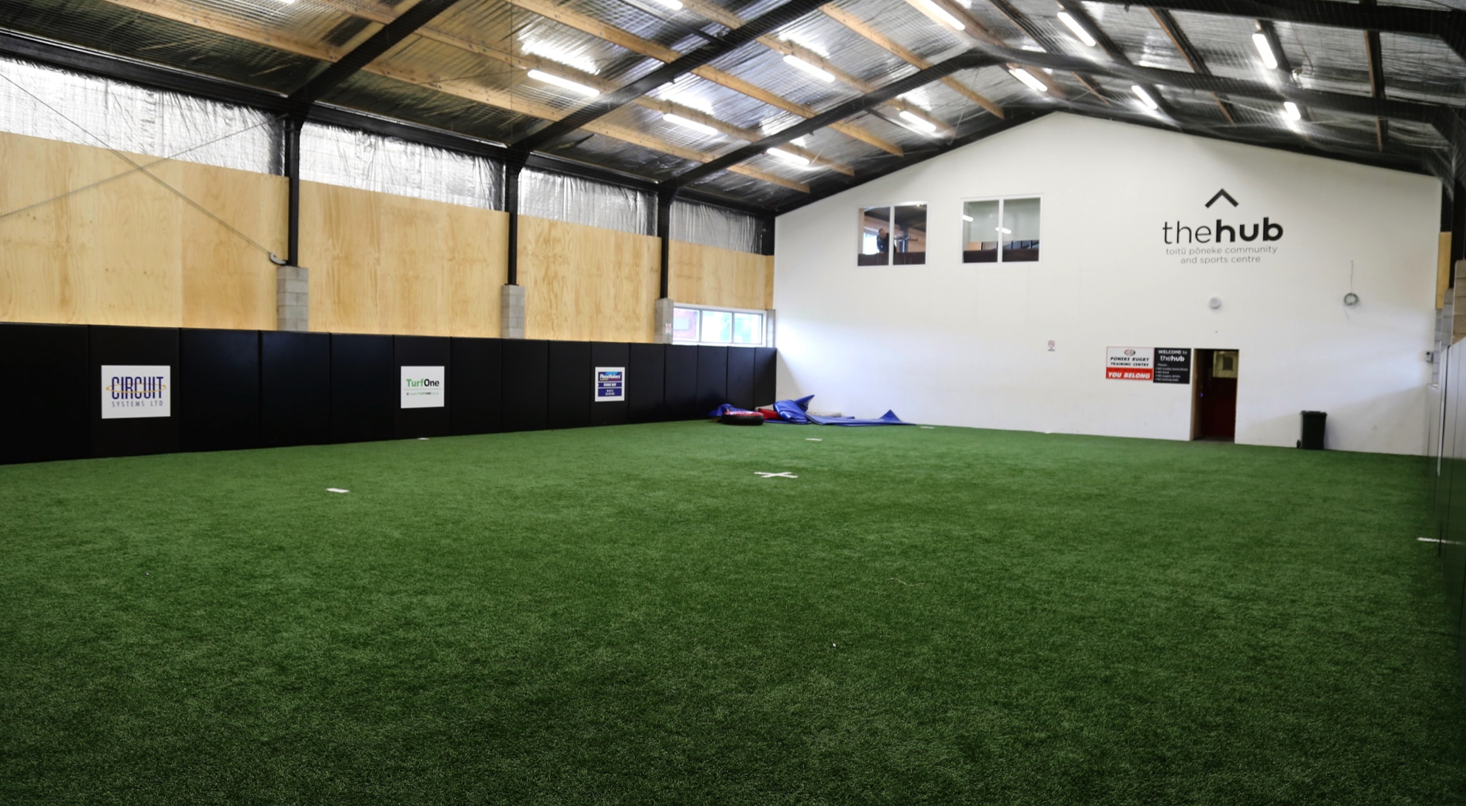

INVITATION TO APPLY FOR A PLACE ON OUR BOARD
Are YOU the right person?

Who Are We?

Toitu Poneke Community & Sports Centre Inc. (Toitu Poneke, or “thehub”) is a provider of social, meeting and training spaces, on Kilbirnie Park, Wellington. With 6 significant sporting clubs making up our diverse membership (currently 1,800 people, including rugby, darts, diving, softball, netball and fencing), thehub also hosts other multiple community groups, family celebrations and corporate meetings. Toitu Poneke also owns and operates “thehub Ltd” who manage and deliver our onsite food & beverage services. Whilst Toitu Poneke is considered a leading hub model in New Zealand, we still have much to achieve.

Our Purpose
To support, strengthen, promote and advocate for sport, active recreation and community groups, for children and adults, and to maximise the facilities, the partnerships and the opportunities the Hub provides.

Our Vision
A dynamic, sustainable and inclusive Hub, that encourages, enables and inspires our community to lead more fulfilling lives through sport, socialisation and active recreation.
Our Values

A All are welcome
C Community is at our heart
T Teamwork is essential
I Integrity in all that we do
V Vibrant environment
E Excellence is our aim

Who We Seek?

We are seeking strategic and innovative thinkers and doers to fill the 2 vacant positions on our Board of seven from May 2021. An understanding of the Sport & Recreation sector would be an advantage, as well as being Community minded / connected. Applicants will need to bring a variety of skills, knowledge and experiences, with cultural, gender and age diversity of importance to our Appointments Panel. The term for Board members is 3 years, with the ability to serve for 2 consecutive terms. As a Board, we meet for 2 hours every 6 -8 weeks, plus some sub-committee work can be expected between meetings.

To Register Your Interest…

Please complete the invitation to apply form below and forward to rossdjamieson@gmail.com – by no later than 5pm on Friday 16 April 2021. Shortlisted applicants will be invited to an interview.

BOARD APPLICATION FORM 2021
1 ELECTED AND 1 APPOINTED POSITION AVAILABLE

Information

- Applications for positions of BOTH Appointed and Elected Board Members of thehub must be made by completing this form. You are welcome to include attachments / CV etc.

- Applications are to be received by Ross Jamieson, Chair of thehub, rossdjamieson@gmail.com, no later that 5pm on Friday 16 April 2021.

- Applications will be welcomed from members of the wider community, including members of our Member Clubs.

- All applications will be referred to thehub Appointments Panel. It will assess the candidates and shortlist them for interviewing. After the interview process, the Appointments Panel will then appoint the Appointed Board Member position, whilst ranking the Elected Members, prior to the vote at thehub AGM on 19 May 2021.

Elected or Appointed Position Sought?

Please indicate (using tick box) if you are applying for an ELECTED position (you must be a member of our one of our member clubs), or an APPOINTED position.

- I am seeking a position as an ELECTED Board Member

Please state your Member Club : __________________________________________________

- I am seeking a position as an APPOINTED Board Member

Personal Details

Surname

First Name

Residential Address

Mobile / Best Phone

Email

Educational Qualifications

Please specify highest educational qualifications, together with any qualifications relevant to this application.

Current Occupational Details

Please advise your current occupational role and job title, along with your current employer, or employment status (e.g. self-employed).

Relevant Work Experience

Period (Years) | Employer (Name) | Position Held / Major Responsibilities
Service : Relevant Sports Associations, Clubs, Schools and/or Community Groups

Period (Years) | Association, Club, School, Organisation (Name) | Position Held / Major Responsibilities

Governance Experience

Please detail below current, and any significant previous, directorships / trusteeships, private or public, paid or volunteer, and governance appointments. Please append a separate sheet if necessary.

Organisation  Name | Period  (e.g. 2013 – 2016) | Role(s)  (e.g. Chair, Board Member, Treasurer, Secretary)
Board Skills Self-Rating

Please provide a self-rating of your abilities to contribute to each of the following areas of the operation, by circling the appropriate number. Your ratings will assist the Appointments Panel in ensuring that the right mix of skills, knowledge and experience is on the Board.

Characteristic | Low |  | Medium |  | High
Skills

Ability to think strategically | 1 | 2 | 3 | 4 | 5
Analytical, critical reasoning & problem solving | 1 | 2 | 3 | 4 | 5
Strong financial literacy & analytical ability | 1 | 2 | 3 | 4 | 5
Oral communication | 1 | 2 | 3 | 4 | 5
Written communication | 1 | 2 | 3 | 4 | 5
Cultural awareness | 1 | 2 | 3 | 4 | 5
Ability to understand & relate to diverse stakeholders | 1 | 2 | 3 | 4 | 5
Attributes

Ethical, open, honest, trustworthy, high integrity | 1 | 2 | 3 | 4 | 5
Independence & inquisitiveness | 1 | 2 | 3 | 4 | 5
Innovative | 1 | 2 | 3 | 4 | 5
Ability to establish quality relationships | 1 | 2 | 3 | 4 | 5
Ability to work as a team player | 1 | 2 | 3 | 4 | 5
Preparedness to work hard & commit time & effort | 1 | 2 | 3 | 4 | 5
Outcome focused | 1 | 2 | 3 | 4 | 5
Strong stewardship orientation / consumer focus | 1 | 2 | 3 | 4 | 5
Experience

Corporate governance experience | 1 | 2 | 3 | 4 | 5
Sport & recreation sector | 1 | 2 | 3 | 4 | 5
Community / stakeholder influence & connections | 1 | 2 | 3 | 4 | 5
Broad business experience | 1 | 2 | 3 | 4 | 5
Marketing / promotion | 1 | 2 | 3 | 4 | 5
Communications / public relations | 1 | 2 | 3 | 4 | 5
Sponsorship, fundraising, community trusts | 1 | 2 | 3 | 4 | 5
Information systems & technology | 1 | 2 | 3 | 4 | 5
Human resources management | 1 | 2 | 3 | 4 | 5
Financial planning & reporting | 1 | 2 | 3 | 4 | 5
Legal | 1 | 2 | 3 | 4 | 5
Health & safety | 1 | 2 | 3 | 4 | 5
Policy & risk | 1 | 2 | 3 | 4 | 5
Venue operations & maintenance | 1 | 2 | 3 | 4 | 5
Meeting Performance

Well prepared and punctual for meetings | 1 | 2 | 3 | 4 | 5
Adds value to Board dialogue | 1 | 2 | 3 | 4 | 5
Able to focus at the governance level of issues | 1 | 2 | 3 | 4 | 5
Able to disagree, without being disagreeable | 1 | 2 | 3 | 4 | 5

Please provide any comments or explanations, relating to the above self-rating, as you see fit (not compulsory).

Confirmation

I hereby confirm the following :

1 | That the information supplied above and attached, is complete and accurate.
2 | That I am willing and available to meet with thehub Appointments Panel, if requested, to discuss my application.
3 | That if elected, or appointed, as a Board Member, I would be available to serve on thehub Board.
4 | That I authorise thehub Appointments Panel to contact any referees I have provided.
5 | That I consent to thehub retaining and using the personal information contained in this form and any attachments, to distribute it to thehub Appointments Panel and to Member Clubs, for the purposes of my application as an appointed, or elected, Board Member. I understand that once the appointments / elections have concluded, this information will be destroyed, unless I agree to it being retained. I understand I have the right to access this information and to change it, if necessary. This consent is given under the Privacy Act.

Signature | Date

